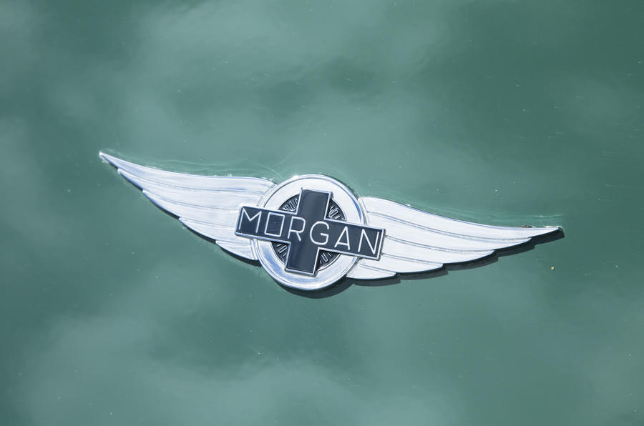

Morgan Motor company and its operations

Student Number:

2020

**Introduction**

Morgan motors is a very old company about 110-year-old, and it is based in Malvern, UK. Morgan motor produces 3-wheeler cars and their designs are five decades earlier. This report will highlight the Morgan motor operations and how its vision is fulfilled through its operations. Morgan motor’s vision is to create mix of traditional and modern feature cars with eco-friendly nature. The main purpose that cover this report is to see are the operations of Morgan motor resemble its vision statement.

**Review of Morgan operations**

This paragraph of the report will highlight 2 things, one is the resemblance of operations with its vision statement and other is shareholders and its satisfaction with the company. Vision of Morgan motor company is to make best quality, innovative designs that are mix of traditional as well as modern features and eco-friendly cars.

Morgan motor organization operations incorporate assembling high-quality vehicles to the vehicle structure industry. Morgan Motors produces vehicles that are eco-friendly in nature and emanation free. Morgan motor story of operations is provided in the video that they make hand made vehicles with wood and aluminum sheet. In the store of Morgan motor, around 200 individuals are working.Older individuals are working and instructed to the youthful specialists with verbal. There is no book of their tasks with the goal that laborers would be told through that. To start with, they structure a wood casing of the vehicle then they spread it with aluminum. Every one of these things are hand-assembled. They likewise have their own paint shop, so as the vehicle is created then that would go in the paint search for shading and logo (The drive, 2013).

Afterwards,they import case from Birmingham and those suspension are worked in the vehicles looking like wires.In addition, they gives the office of keeping up and overhauling of the new vehicle or trade-in vehicles. Morgan said we are centered around passing on a first class, singular help. During the continued with the satisfaction of our customers shows reliably, there's no spot like home while upgrading your Morgan.For Instance, they give 3 sorts of administration, health check, Trim, and paint.

**Health check**: Regardless of whether you are getting your Morgan out in desire for the Summer, setting it into hibernation for the Winter, or going to set out on a go across terrain trip, a prosperity check could be for you. In the health check Morgan give the accompanying administrations as below:

* Outer
* Underbonnet
* Electrical
* Underside
* Wheels and tires
* Brakes and centers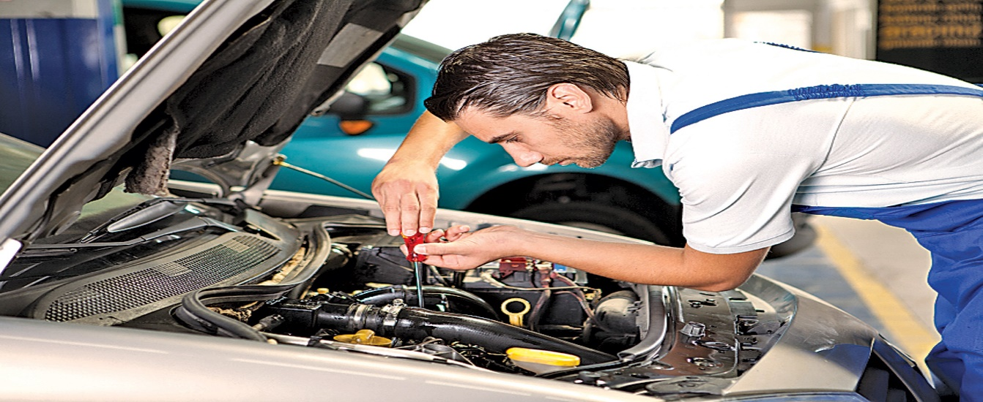

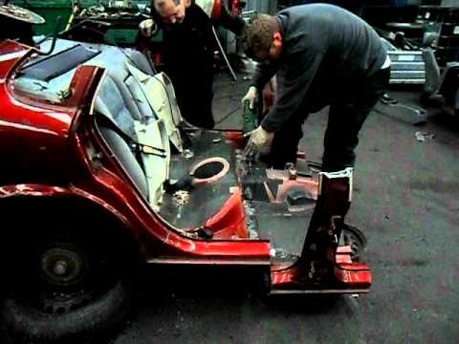**Trim**: All things considered, we can give nourishment to trim work running from a minor seat fix through to an absolute re-trim.However, our workshop can source 'like for like' calfskin, with all work being finished by the identical masters and women that trim each Morgan.

**Paint:** Morgan Works servicing is fulfilled to work near to the preparing plant paint and availability divisions. Done by the various proportional talented gifted laborers who paint each new Morgan, we can energize everything from a sharp fix through to all out re-spray.

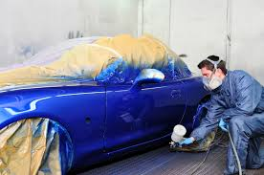

With the tasks and benefits of the organization these partners will be fulfilled:

1.Shareholders: Shareholders are giving cash to the organization. Morgan engine organization is getting benefits and brand value that is profiting the organization's investors as its offer cost is expanding in the market throughout the time.

**2.Management group and representatives:** Management group and workers of the Morgan organization are remunerated by the offer in the business since Morgan engines get the proportion of speculation from Invest industrial value.On the other hand, representatives have given the best remarks for the organization that there is a perfect and upbeat condition at Morgan Motors, they appreciate working in that organization due to the well disposed nature of the organization proprietor and different representatives.

**Society and its kin:** As the organization has referenced that they are giving eco-accommodating autos that are sans discharges that would be useful for society and nature in which individuals are living. The clients are additionally content with the administration of Morgan Motors and give utmost 5 stars evaluations to the organization and best remarks on its quality.

**Conclusion**

We have investigated the Morgan Motors organization and come to think about its tasks that what sort of activities they have and what sort of administrations they are giving to the clients. Moreover,we infer that they are working as indicated by its vision as its vision is to blend conventional in with present day exercises in the eco-friendly condition. Morgan engine's vision is plainly noticeable in its activities and its partners are content with its tasks and administration that they are giving.

**References**

The drive, (2013). Morgan Motor company: The most honest car factory in the world. [online]. Available at: <https://www.youtube.com/watch?v=OJLcoGMPQ94> [Accessed 16 February 2020].